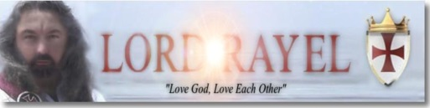

The CREED

1. I believe in God the Father almighty, creator of the heavens and earth.
2. I believe in Yeshua the Christ, His transcendent Son, our Lord.
3. He was conceived by the power of the Holy Spirit and born to mankind.
4. He was crucified, died, and was buried.
5. He descended to the dead; on the third day he rose again.
6. He ascended into heaven and was seated at the right hand of The Father.
7. He has come again to judge the living and the dead.
8. I believe in the Word of God, the returned Christ, Lord RayEl.
9. In His great commandment: Love God, Love Each Other.
10. In the holy Ecumenical Order of Christ.
11. The forgiveness of sins.
12. The resurrection of the body and life everlasting.
Amen.
